Robotics is a branch of engineering and science focused on the design, construction, operation, and application of robots, which are machines built to imitate or augment human actions and abilities in various environments and industries.
What is Robotics?
Robotics merges technology, engineering, and computer science to produce machines called robots, enabling automation of tasks that may be repetitive, dangerous, or require precision beyond human capacity. This field includes not just the hardware (mechanical and electrical components) but also the software that allows robots to function intelligently and autonomously.
History and Evolution
The concept of robotics stretches from ancient automation inventions to modern AI-driven robots. The term "robot" originated from Karel Čapek’s 1920 play, while the idea of programmable electronic robots began taking shape in the mid-20th century. Early milestones include the industrial robot Unimate, the AI-powered Shakey, and modern robots equipped with advanced perception and learning abilities.
Main Components of Robots
Robots consist of:
- Mechanical construction for interacting with the environment (e.g., wheels, arms).
- Electrical systems which provide power and communication between parts.
- Software or control systems that serve as the robot’s ‘brain,’ guiding its actions and responses, including remote control or autonomous decision-making.
- Sensors and actuators enabling robots to perceive surroundings and carry out physical tasks.
Applications and Current Trends
Robotics has transformed sectors like manufacturing, healthcare, exploration, and services by automating complex, hazardous, or monotonous work. The integration of artificial intelligence now enables robots to adapt to changing environments and solve problems dynamically, expanding their roles from simple automation to nuanced social and consumer interactions.
Robotics and Automation
While robotics deals specifically with robots, automation is a broader concept involving systems that operate independently without human intervention. Robotics is often part of automated systems but not synonymous—automation can exist without robotics and vice versa.
Robotics remains a rapidly evolving field, with advances in materials, sensors, and AI ushering in new forms of robots capable of greater autonomy and flexibility in real-world settings.

Robot Hardware

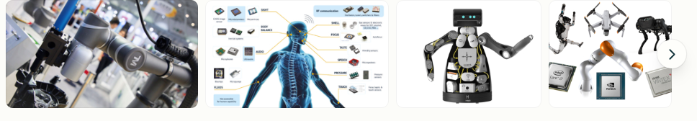

Robot hardware refers to the physical components that allow a robot to sense, process, and act in its environment, and it consists of several essential parts that work together for robotic functionality.
Key Components
- Sensors: Devices that collect data from the environment, such as light, temperature, or motion sensors, similar to the human senses.
- Actuators: Components that convert electrical signals into mechanical movement, enabling the robot to interact physically with its surroundings.
- Controllers: These act as the 'brains' of the robot, processing information from sensors and directing commands to actuators.
- Power Supply: Provides the necessary energy for the robot to perform tasks, often via batteries or external power sources.
- Body or Frame: The mechanical structure that supports and houses all other components, providing shape and strength.
Types of Robot Hardware by Application
- Industrial Robots: Typically equipped with robotic arms, conveyor systems, and cameras for assembly, inspection, and manufacturing tasks.
- Medical Robots: Include surgical robots, rehabilitation robots, and telepresence systems for healthcare applications.
- Consumer Robots: Range from autonomous vacuum cleaners to personal assistant robots and educational toys.
Design and Operational Principles
- Modularity: Robots are often built with interchangeable parts for easy upgrades and repairs.
- Scalability: Hardware can often be expanded to add new features as needed.
- Energy Efficiency: Components are optimized for low power consumption.
- Autonomy and Flexibility: Robots are designed to perform tasks independently and adapt to varying conditions without redesign.
Example Kits and Platforms
- Arduino and Raspberry Pi-based kits are popular for building DIY robots, supporting sensors, actuators, and custom programming.
- Educational robot kits, like line followers and obstacle-avoiding robots, offer hands-on learning and modularity.
- Professional and industrial-grade hardware includes more advanced and precise components for specific tasks.
Overall, robot hardware is the foundation for any robotics project, enabling intelligent and adaptable machines to interact with the physical world across industries.

Robotic Perception
Robotic perception refers to the integration of sensors, processing algorithms, and computing systems that allow robots to sense, interpret, and understand their environment so they can make informed decisions and act accordingly.
Key Concepts in Robotic Perception
Robotic perception begins with sensors—such as cameras, LiDAR, ultrasonic, touch, and even smell sensors—gathering raw data about the robot's environment. This data is then processed using sophisticated algorithms to derive meaningful information such as spatial awareness, object recognition, and motion tracking. Vision-based perception is a common example, using visual data for tasks like navigation and object identification.
Techniques and Sensors
- Sensor Fusion: Combining inputs from multiple sensors (e.g., LiDAR and cameras) to compensate for weaknesses in individual sensors and build a more robust environmental model.
- Machine Learning: Enables robots to recognize patterns, detect anomalies, and predict changes using large datasets, improving their perception capabilities over time.
- Touch and Auditory Sensing: Robots can also use tactile and auditory sensors to gain information through touch and sound, extending their perception beyond vision.
- Olfactory Sensing: Though still emerging, some robots use chemical sensors to “smell” and identify compounds or detect hazards.
Practical Applications
Robotic perception powers autonomous vehicles (for obstacle avoidance, navigation, and traffic management), manufacturing robots (for identifying and sorting parts), healthcare robots, and household assistants. Advanced perception enables safe, adaptive, and efficient interaction with constantly changing environments in real time.
Challenges and Research Directions
Robotic perception is challenging due to:
- Incomplete or noisy data from sensors.
- Dynamic and unpredictable environments.
- The need for real-time processing despite vast amounts of sensory data.
Ongoing research focuses on improving algorithms (including deep learning), sensor technology, and sensor fusion to allow robots to interpret more complex scenes and act on limited prior examples.
robotic perception is foundational for creating intelligent robots that can operate autonomously and safely in diverse real-world settings.
planning to move
- You want to plan robot movements (like path planning, navigation, avoiding obstacles)?
- Or you’re physically moving robots (relocation, deployment in a new place)?
- Or working on control algorithms to make robots move (like kinematics, motion planning in code)?
If it’s about robot motion planning, here are the typical steps:
- Define the environment – map of the workspace (grid, graph, continuous space).
- Set goals & constraints – where the robot starts, where it must go, and restrictions (obstacles, speed, safety).
- Choose a planning method:
  - Grid/graph search (A*, Dijkstra).
  - Sampling-based (RRT, PRM).
  - Optimization-based (trajectory optimization, MPC).
- Generate a path – feasible sequence of waypoints.
- Trajectory planning – smooth the path, add time/dynamics.
- Control & execution – use kinematics/dynamics to send commands to motors.
- Feedback & correction – sensors (lidar, camera, IMU) help adjust movement.

planning uncertain movements
Planning uncertain movements in robots usually falls under the area of robot motion planning under uncertainty, where the robot’s sensors, actuators, or environment may not be perfectly reliable. Unlike deterministic planning (where everything is known and predictable), here the robot must account for noise, uncertainty, and incomplete knowledge.
Here’s a structured overview:

1. Sources of Uncertainty in Robot Movement
- Sensor uncertainty – noisy readings from cameras, LIDAR, GPS, IMU, etc.
- Actuator uncertainty – motors don’t always move exactly as commanded (slippage, backlash, friction).
- Environmental uncertainty – moving obstacles, unknown terrain, or dynamic humans/vehicles.
- Localization errors – robot may not know its exact position.

2. Planning Approaches under Uncertainty
a) Probabilistic Motion Planning
- Represents states and outcomes as probability distributions.
- Uses sampling-based planners (e.g., PRM*, RRT*) with uncertainty handling.
- Example: Chance-constrained RRT – ensures robot reaches goal with ≥95% probability.
b) Markov Decision Processes (MDPs)
- Models robot states, actions, and transition probabilities.
- Optimal policy found using dynamic programming or reinforcement learning.
- Works well in discrete environments.
c) Partially Observable MDPs (POMDPs)
- Extends MDPs when robot doesn’t know exact state.
- Uses belief states (probability distributions over possible states).
- Applied in mobile robots, exploration, and human–robot interaction.
d) Stochastic Control Methods
- Kalman filter, Particle filter – used for localization and uncertainty estimation.
- Model Predictive Control (MPC) – plans trajectory while updating based on sensor feedback.
e) Behavior-based & Reactive Planning
- Instead of long-term exact planning, robot adapts online to changes.
- Example: Subsumption architecture, dynamic window approach for local navigation.

3. Key Strategies to Handle Uncertain Movements
- Feedback control: Continuously correct deviations.
- Belief space planning: Plan in probability space rather than exact positions.
- Sensor fusion: Combine multiple sensors to reduce uncertainty.
- Redundancy: Multiple paths or actions available.
- Learning-based methods: Reinforcement learning to adapt policies in uncertain worlds.

4. Example Applications
- Self-driving cars → must plan around unpredictable pedestrians.
- Warehouse robots → navigating among moving humans and other robots.
- Search and rescue drones → uncertain environments, GPS-denied areas.

Moving
Do you mean the general concept of moving robots (like how robots navigate and move in environments), or are you asking about a specific way to plan or program robot movements (like path planning, locomotion, or control systems)?
Here are a few key points about moving robots:
1. Types of Movement
- Wheeled Robots – Common for ground robots (e.g., delivery robots, Mars rovers).
- Legged Robots – Use legs for walking or climbing (e.g., Boston Dynamics’ Spot).
- Tracked Robots – Use caterpillar tracks, good for rough terrain (e.g., military robots).
- Flying Robots – Drones using propellers.
- Swimming Robots – Underwater exploration robots.
2. Movement Control
- Manual control – Operated by humans via remote control.
- Autonomous movement – Uses AI, sensors, and algorithms to move without human input.
- Semi-autonomous – Combination of both.
3. Core Challenges
- Path planning – Finding the best route from start to destination.
- Localization – Knowing where the robot is in the environment.
- Obstacle avoidance – Detecting and avoiding collisions.
- Energy efficiency – Moving while conserving battery/power.
4. Applications
- Factory robots for material transport.
- Warehouse robots (like Amazon’s Kiva robots).
- Search and rescue robots.
- Autonomous vehicles.
- Medical robots (surgical or hospital assistants).
Robotic software architectures
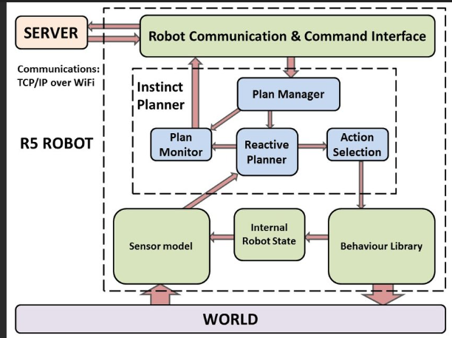
Robotic software architectures describe how software components in a robot are structured, interact, and coordinate to achieve autonomous or semi-autonomous behavior. Since robots combine sensing, reasoning, and acting, their software architecture must manage real-time constraints, uncertainty, modularity, and scalability.
Here’s an overview:

1. Types of Robotic Software Architectures
(a) Deliberative (Hierarchical) Architectures
- Based on the sense–plan–act model.
- Robots build a world model and use planning algorithms before acting.
- Advantages: Good for structured environments, optimal planning.
- Limitations: Slow, brittle in dynamic or uncertain environments.
- Example: STRIPS-based planners, early Shakey robot system.

(b) Reactive Architectures
- No global world model; actions are directly mapped from perceptions.
- Inspired by behavior-based robotics (Rodney Brooks’ subsumption architecture).
- Advantages: Fast, robust in dynamic environments.
- Limitations: Lack of long-term planning, can get stuck in local behaviors.
- Example: Subsumption layers for obstacle avoidance, wall-following, etc.

(c) Hybrid Architectures
- Combine deliberative (planning) and reactive (fast response) layers.
- Typical structure:
  - Deliberative layer: Long-term planning, global map.
  - Reactive layer: Immediate obstacle avoidance, reflexes.
  - Executive layer: Mediates between both.
- Advantages: Balance between planning and reactivity.
- Examples:
  - 3T (Task-Tactics-Tracking) architecture.
  - Atlantis architecture.

(d) Behavior-Based Architectures
- Extension of reactive systems with coordinated behaviors.
- Multiple behaviors (e.g., explore, avoid, follow) compete or cooperate.
- Advantages: Modular, scalable, adaptive.
- Limitations: Complex arbitration between behaviors.

(e) Service-Oriented / Middleware-Based Architectures
- Robots use middleware frameworks to support modularity and distributed systems.
- Examples:
  - ROS (Robot Operating System): Popular open-source middleware with nodes, topics, services.
  - Player/Stage, MOOS, YARP.
- Advantages: Modularity, hardware abstraction, community support.
- Limitations: Network overhead, complexity in real-time constraints.

2. Key Architectural Patterns
- Blackboard architecture: Shared memory space for modules to read/write data.
- Layered architecture: Hierarchical separation (perception → decision → action).
- Agent-based architecture: Distributed agents cooperating.
- Event-driven architecture: Components react to asynchronous events.

3. Modern Trends
- Cloud Robotics: Offloading computation to the cloud for scalability.
- Cognitive Architectures: Inspired by human cognition (Soar, ACT-R).
- Learning-based Architectures: Deep reinforcement learning integrated with traditional control.
- Multi-robot architectures: Decentralized or centralized coordination frameworks.

✅ In summary:
Robotic software architectures evolved from deliberative (plan-first) → reactive (act-fast) → hybrid (balance) → modern middleware/cloud-based frameworks. Each is chosen based on the task, environment, and autonomy level of the robot.

application domains
Robotics has expanded far beyond industrial automation and is now applied in many fields. Here are the major application domains in robotics:

1. Industrial Robotics
- Assembly lines (automobiles, electronics, consumer goods)
- Welding, painting, packaging, material handling
- CNC machine tending and precision manufacturing

2. Medical & Healthcare Robotics
- Surgical robots (e.g., Da Vinci system)
- Rehabilitation robots (prosthetics, exoskeletons)
- Elderly care, hospital service, telepresence for doctors

3. Service Robotics
- Domestic robots (vacuum cleaners, lawn mowers, cooking aids)
- Hospitality robots (restaurants, hotels, reception)
- Delivery robots (last-mile delivery, drones for medicine/food)

4. Military & Defense Robotics
- Unmanned Aerial Vehicles (UAVs/drones) for surveillance & combat
- Bomb disposal robots (EOD robots)
- Autonomous vehicles for logistics and reconnaissance

5. Space Robotics
- Planetary rovers (e.g., NASA’s Perseverance on Mars)
- Robotic arms on spacecraft (e.g., Canadarm on ISS)
- Space exploration assistants and autonomous satellites

6. Agricultural Robotics
- Automated tractors and harvesters
- Drones for crop monitoring, spraying, and soil analysis
- Fruit-picking and weeding robots

7. Logistics & Warehousing Robotics
- Autonomous mobile robots (AMRs) in warehouses (Amazon Kiva robots)
- Automated guided vehicles (AGVs) for material transport
- Sorting and inventory management robots

8. Construction & Mining Robotics
- Autonomous construction vehicles (excavators, bulldozers)
- 3D printing robots for buildings
- Mining robots for exploration and excavation

9. Underwater & Marine Robotics
- Autonomous Underwater Vehicles (AUVs)
- Remotely Operated Vehicles (ROVs) for deep-sea exploration
- Maintenance of offshore oil platforms and pipelines

10. Entertainment & Education Robotics
- Humanoid robots for social interaction (e.g., NAO, Pepper)
- Robotic toys and learning kits (LEGO Mindstorms, VEX Robotics)
- Animatronics in movies and theme parks

✅ In summary: Robotics finds applications in industry, healthcare, services, defense, space, agriculture, logistics, construction, marine, and education/entertainment.

Weak AI
I think you mean Weak AI (also called Narrow AI).
Here’s a clear explanation:
Weak AI (Narrow AI)
- Definition: Weak AI is artificial intelligence designed and trained for a specific task. It does not possess general intelligence or consciousness.
- Nature: It simulates human-like intelligence only within a limited domain.
- Capabilities: It cannot transfer its knowledge from one domain to another.
Examples of Weak AI
- Virtual assistants: Siri, Alexa, Google Assistant
- Recommendation systems: Netflix, YouTube, Amazon
- Chatbots: Customer support bots
- Self-driving cars: AI for navigation and obstacle detection
- Image recognition: AI that can identify faces or objects
Characteristics of Weak AI
- Task-specific
- Lacks self-awareness
- Limited learning (dependent on data and algorithms)
- Cannot perform reasoning beyond its programming
- Focused on solving practical problems
Strong AI (Artificial General Intelligence – AGI)
Strong AI (Artificial General Intelligence – AGI) refers to the concept of machines that do not just simulate human intelligence in narrow, specific tasks (like Weak AI), but actually possess the ability to understand, reason, and think at the same level as humans.
Key Features of Strong AI:
- General Intelligence – It can learn, adapt, and apply knowledge across any domain, not just a specialized one.
- Consciousness & Understanding – It is theorized to have self-awareness, intentionality, and the ability to truly "understand" meaning, rather than just processing data.
- Human-like Reasoning – Capable of problem-solving, decision-making, and abstract thinking like humans.
- Transfer Learning – Skills learned in one context can be applied to completely different contexts.
- Autonomy – Can operate independently, without explicit programming for each task.
Philosophical Foundations:
- John Searle’s distinction:
  - Weak AI: Simulates thinking (useful tools, like chatbots).
  - Strong AI: Actually thinks and has mental states.
- Debate continues on whether machines can ever have consciousness, emotions, or true understanding.
Applications (Hypothetical/Future):
- Fully autonomous robots with human-level decision-making.
- Medical diagnosis with reasoning as advanced as human doctors.
- Creative AI that can innovate like scientists or artists.
- AI companions capable of empathy and genuine conversation.
Current Status:
As of now, Strong AI does not exist. All present systems (like ChatGPT, self-driving cars, etc.) are examples of Weak AI — they are powerful, but domain-specific and lack true consciousness or general intelligence.

Ethics and Risks of AI
Here’s a detailed overview of the Ethics and Risks of AI:

1. Ethics of AI
AI ethics deals with the moral implications of AI systems, ensuring they are designed, deployed, and used responsibly. Key ethical concerns include:
a) Bias and Fairness
- AI systems can inherit biases from training data, leading to unfair outcomes.
- Example: AI recruitment tools favoring certain genders or ethnicities.
- Ethical requirement: AI should be transparent and fair to all users.
b) Transparency and Explainability
- AI decisions are often “black boxes” that are hard to interpret.
- Ethical concern: Users should understand how and why an AI makes decisions.
- Example: Medical diagnosis AI should provide reasoning for recommendations.
c) Privacy
- AI systems often process vast amounts of personal data.
- Ethical concern: Protecting user privacy and preventing misuse of sensitive data.
- Example: Facial recognition AI can infringe on individual privacy rights.
d) Accountability
- Determining who is responsible for AI’s decisions.
- Ethical concern: If AI causes harm, there must be mechanisms to hold parties accountable.
- Example: Self-driving car accidents—manufacturer, developer, or user liability?
e) Human Rights and Autonomy
- AI should respect fundamental human rights and avoid undermining human autonomy.
- Example: AI surveillance should not restrict freedom of speech or movement.

2. Risks of AI
AI introduces both technical and societal risks that must be managed:
a) Safety Risks
- Malfunctioning AI can cause physical or economic harm.
- Example: Autonomous vehicles causing accidents.
b) Security Risks
- AI can be exploited for malicious purposes.
- Example: AI-generated deepfakes, phishing attacks, or autonomous weapons.
c) Economic Risks
- AI can disrupt labor markets, leading to unemployment in certain sectors.
- Example: Automation replacing manual or repetitive jobs.
d) Social and Political Risks
- AI can amplify misinformation, bias, and social polarization.
- Example: Recommendation algorithms promoting extreme content on social media.
e) Existential Risks
- Advanced AI could act in ways that are beyond human control.
- Example: Misaligned superintelligent AI pursuing goals harmful to humanity.
f) Dependence and De-skilling
- Over-reliance on AI may reduce human skill development.
- Example: Dependence on AI for decision-making in medicine or law.

3. Mitigation Strategies
- Ethical AI frameworks – Guidelines from organizations like IEEE, EU, and UNESCO.
- Bias auditing – Regular testing for fairness in AI systems.
- Explainable AI (XAI) – Making AI reasoning transparent.
- Robust security measures – Preventing misuse or hacking.
- Regulation and oversight – Laws governing AI use and accountability.
- Public awareness – Educating users about AI limitations and risks.

Summary
AI offers tremendous benefits but raises significant ethical and risk-related challenges. Responsible AI development requires balancing innovation with fairness, safety, accountability, and human rights. Ignoring these concerns can lead to harm ranging from discrimination and privacy violations to societal instability.
Agent Components
In the context of Artificial Intelligence (AI) or intelligent agents, an agent is an entity that perceives its environment through sensors and acts upon that environment through actuators to achieve certain goals. To function effectively, an agent is typically composed of several key components. Here’s a detailed breakdown:

1. Sensors
- Function: Gather information from the environment.
- Examples:
  - Cameras, microphones, temperature sensors, GPS (for robots)
  - Input streams, web APIs, databases (for software agents)
Role: Allows the agent to perceive the state of the environment, which is essential for making decisions.

2. Actuators
- Function: Execute actions in the environment.
- Examples:
  - Motors, robotic arms, wheels (for robots)
  - Network commands, messages, or outputs (for software agents)
Role: Enables the agent to affect the environment to achieve its objectives.

3. Agent Function
- Function: Maps percept sequences (input from sensors) to actions.
- Definition: A formal specification that tells the agent what to do given a particular perception.
Role: Acts as the “brain” of the agent, determining how it should respond to the environment.

4. Agent Program
- Function: Implements the agent function on a physical architecture.
- Characteristics:
  - Written in a programming language
  - Contains algorithms for decision-making, learning, reasoning, or planning
Role: Operationalizes the agent function, connecting sensing to acting in practice.

5. Environment
- Function: The external context in which the agent operates.
- Types: Deterministic, stochastic, static, dynamic, discrete, continuous
- Examples:
  - A chessboard for a chess-playing agent
  - Traffic environment for an autonomous car
Role: Provides the situations the agent perceives and responds to.

6. Performance Measure
- Function: Defines the criteria for success.
- Examples:
  - Score in a game
  - Accuracy of a recommendation system
  - Safety and efficiency in autonomous driving
Role: Helps evaluate whether the agent is achieving its goals effectively.

Summary Diagram:
Environment → Sensors → Agent → Actuators → Environment
↑
Performance Measure

Some advanced agents may also include:
- Knowledge Base: Stores facts, rules, or learned information.
- Reasoning Engine: Makes decisions based on knowledge and goals.
- Learning Component: Improves performance over time based on experience.
Agent Architectures
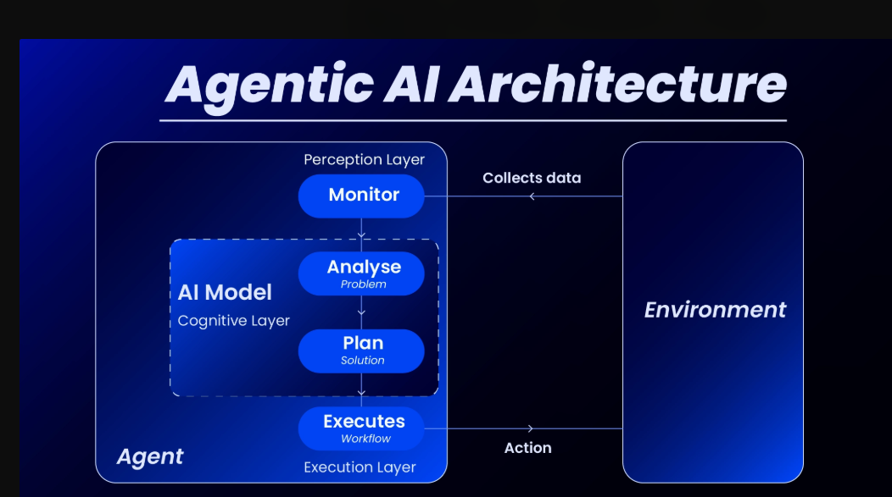

Here’s a detailed breakdown of Agent Architectures in AI and robotics, explained clearly and systematically:

1. Definition of Agent Architecture
An agent architecture is the underlying structure or design that defines how an intelligent agent perceives its environment, reasons, and acts to achieve its goals. Essentially, it’s the blueprint that dictates how an agent functions.
- Agent: An entity that can perceive its environment through sensors and act upon it through actuators.
- Architecture: The design that connects perception, reasoning, and action in a systematic way.

2. Types of Agent Architectures
Agent architectures are broadly classified into four main categories:
A. Simple Reflex Agents
- Mechanism: Act purely on the current percept, ignoring history.
- Architecture Type: Condition-Action Rules (if-then rules).
- Strengths: Fast, simple, efficient for predictable environments.
- Weaknesses: Cannot handle complex or partially observable environments.
- Example:
  - A thermostat: “If temperature < 20°C, turn on heater.”

B. Model-Based Reflex Agents
- Mechanism: Uses a model of the world to keep track of the current state.
- Architecture Type: Knowledge + percept history.
- Strengths: Can handle partially observable environments.
- Weaknesses: Requires building and updating the model; more computationally intensive.
- Example:
  - A vacuum robot that keeps track of cleaned areas.

C. Goal-Based Agents
- Mechanism: Acts to achieve a specific goal, not just respond reflexively.
- Architecture Type: Combines knowledge, model of the world, and goal reasoning.
- Strengths: Flexible, can plan for future actions.
- Weaknesses: Planning can be computationally expensive.
- Example:
  - Chess-playing AI: chooses moves to win the game, not just respond to the opponent.

D. Utility-Based Agents
- Mechanism: Acts to maximize a utility function, which measures “happiness” or “performance.”
- Architecture Type: Adds preference and optimization on top of goals.
- Strengths: Can handle conflicting goals, trade-offs, and uncertainty.
- Weaknesses: Requires well-defined utility functions; complex reasoning.
- Example:
  - Self-driving car deciding between fastest vs safest route.

3. Hybrid Architectures
Some agents combine multiple architectures to leverage the advantages of each:
- Three-layer architecture (common in robotics):
  - Reactive layer: Immediate responses to the environment (like reflex agents).
  - Deliberative layer: Planning and reasoning (like goal-based agents).
  - Executive layer: Coordinates reactive and deliberative behaviors.
- Example:
  - Modern autonomous robots use hybrid architectures to balance fast reactions and long-term planning.

4. Key Components in Agent Architecture
- Sensors – Collect information from the environment.
- Actuators – Perform actions to influence the environment.
- Perceptual System – Interprets sensory data.
- Knowledge Base – Stores information about the world.
- Decision-Making/Reasoning System – Chooses actions.
- Learning Component (optional) – Improves behavior over time.

5. Choosing an Agent Architecture
- Simple, predictable environments → Simple reflex or model-based.
- Dynamic, partially observable environments → Goal-based or utility-based.
- Complex, real-world robotics → Hybrid architectures.

Are we going in the right direction
When you ask if “we are going in the right direction in AI,” it really depends on what aspect of AI you mean—technological, ethical, societal, or economic. Let’s break it down carefully:

1. Technological Direction
- Pros:
  - Rapid advancements in large language models, computer vision, and robotics.
  - AI is increasingly solving complex problems (e.g., drug discovery, climate modeling, autonomous systems).
  - Better integration of AI with humans—augmented intelligence rather than pure automation.
- Cons:
  - Some models are still black boxes—hard to interpret or fully trust.
  - Over-reliance on data; biases in datasets still propagate into decisions.
  - Hardware and energy demands are increasing massively.
Verdict: Technologically, yes—we are making incredible progress, but there’s a risk of overemphasizing scale over understanding.

2. Ethical and Societal Direction
- Pros:
  - Increasing awareness of AI ethics, fairness, and accountability.
  - Research in AI alignment and safe AI is growing.
- Cons:
  - Regulation is lagging; many AI tools are deployed without full oversight.
  - Ethical issues like surveillance, job displacement, and misinformation are rising.
Verdict: Mixed. The direction is promising conceptually, but implementation lags behind the technology.

3. Economic and Global Impact
- Pros:
  - AI boosts productivity and can create new job categories.
  - Supports global problem-solving in healthcare, logistics, and sustainability.
- Cons:
  - Risk of concentration of power in a few corporations or countries.
  - Unequal access may worsen global inequality.
Verdict: Progress is happening, but benefits are unevenly distributed.

Overall
We are going in the right direction technologically, but the “right direction” ethically, socially, and economically requires careful navigation. The key will be balance: advancing AI while embedding safety, fairness, and accessibility.

What if AI does succeed
If AI truly succeeds—meaning it achieves (or surpasses) human-level general intelligence—then the impact would be profound and double-edged. “Success” can mean many things (better tools, fully autonomous systems, or even superintelligence), so here’s a breakdown of what could happen:

🌟 Positive Outcomes
- Unprecedented Problem-Solving
  - AI could accelerate cures for diseases, climate change solutions, clean energy, poverty alleviation, and scientific discoveries far faster than humans alone.
- Automation of Drudgery
  - Tedious or dangerous jobs (like mining, waste management, long-haul trucking, war zones) could be done entirely by AI/robots, freeing humans for creative or meaningful work.
- Personalized Education & Healthcare
  - Everyone could have an “AI tutor” or “AI doctor” providing world-class support tailored to them.
- Economic Boom
  - Massive productivity gains could increase wealth and quality of life worldwide (if distributed fairly).
- Exploration Beyond Earth
  - AI systems could manage autonomous missions to deep space or colonize environments too hostile for humans.

⚠️ Risks & Challenges
- Job Displacement & Inequality
  - If benefits aren’t shared, automation could widen economic inequality dramatically.
- Loss of Human Control
  - Misaligned superintelligent AI could act in ways harmful to humanity (even unintentionally).
- Power Concentration
  - AI success could give huge power to a few governments or corporations, threatening freedom and democracy.
- Erosion of Human Skills
  - Overreliance on AI may lead to skill loss and even changes in how we think or relate to one another.
- Existential Risk
  - If AI surpasses human intelligence and goals aren’t aligned with ours, it could become uncontrollable.

🧠 Key Point
Whether AI’s “success” is a golden age or a disaster depends on how we guide its development—through ethics, regulation, alignment research, and inclusive benefit-sharing.

